How to Become a Volunteer

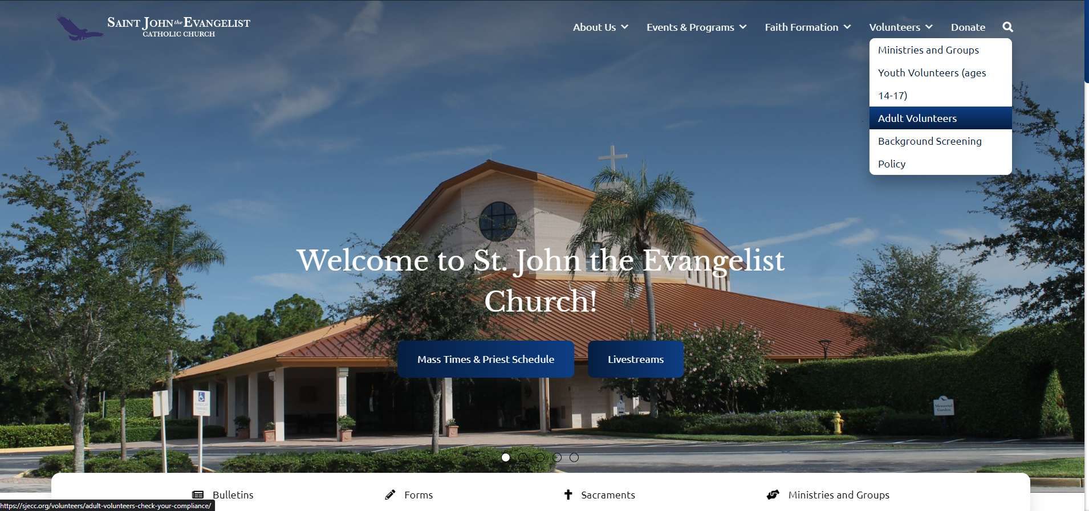
- First go to sjecc.org, then click on adult volunteers from the volunteer drop down menu

- Once there follow the steps below. You will need to complete safe environment training as well as fingerprinting and a background check.

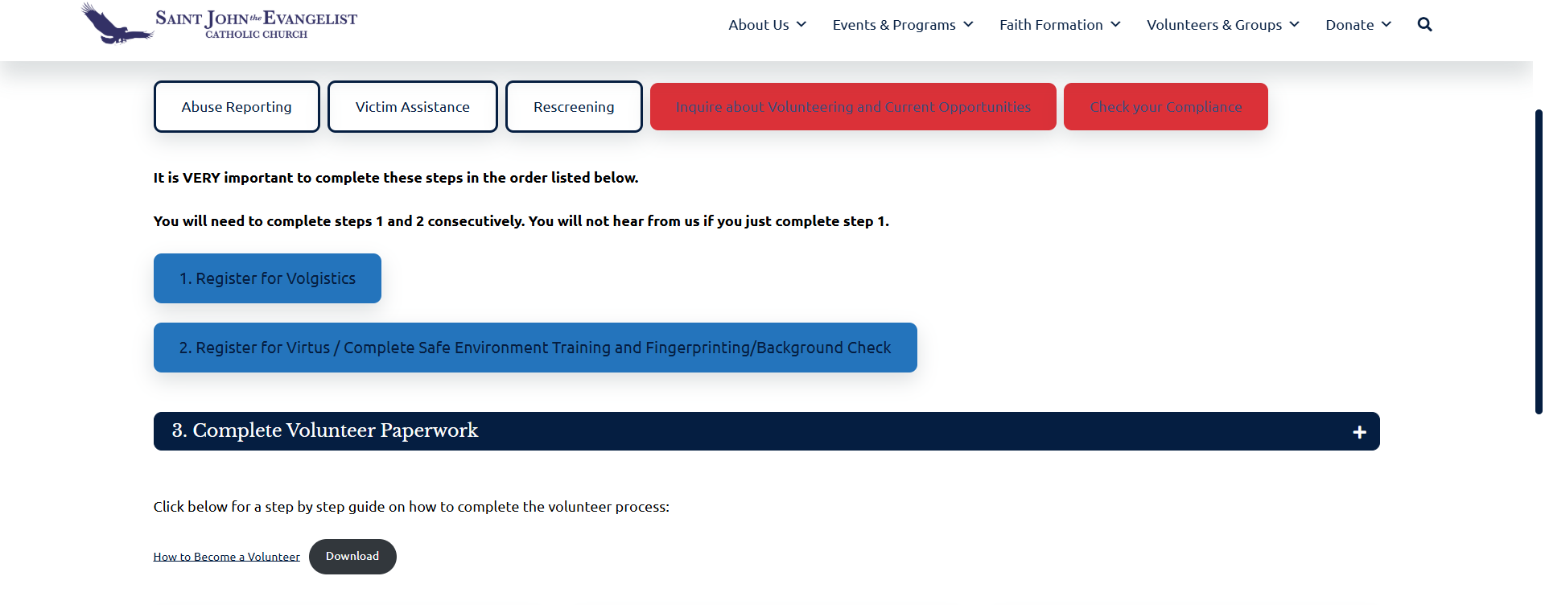

- Volgistics is registering with the Diocese of Venice as a volunteer. Fill out all fields and submit.

- Virtus is for the Safe Environment Training and fingerprinting/background check, you will have to sign in in order to complete the training. Click on first time registrant and it will have you create a username and password. (it will ask you to select the Diocese from a list, note that it is under Venice, Diocese). If you have registered before you will just need to log in with your username and password.

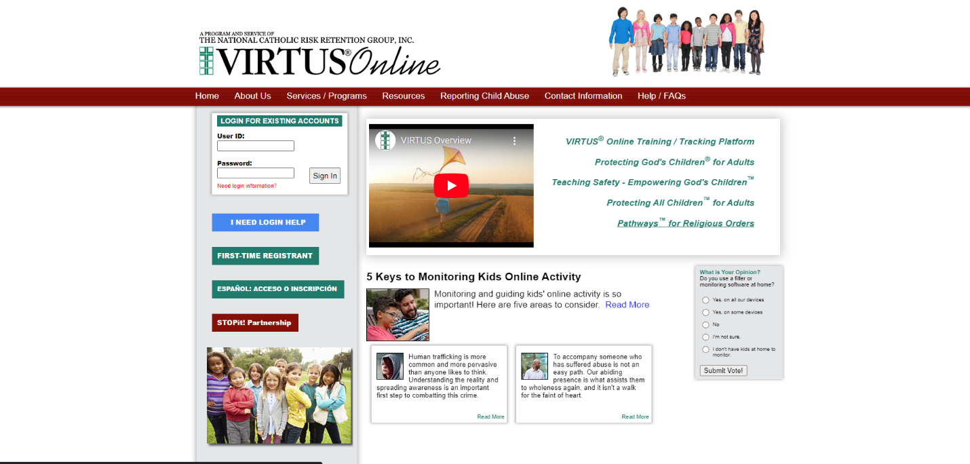

- For safe environment training you will watch a video and answer questions. At the end you will be given a certificate.
- For Fingerprinting stay on the Virtus website. On the home screen click on Fingerprint Check in yellow. Then click on the link to register. Follow the steps by entering in your personal information then continue to appointment scheduling, and then afterwards, payment. Once completed you will receive an email with a QR code that is required to be presented at the time of your appointment.

- Please note: Florida ORI Number =
- Volunteer – Parish = for all parish volunteers
- Employee/Clergy = for all employees, contactor vendors and or clergy for the Diocese of Venice (Parishes and Schools).
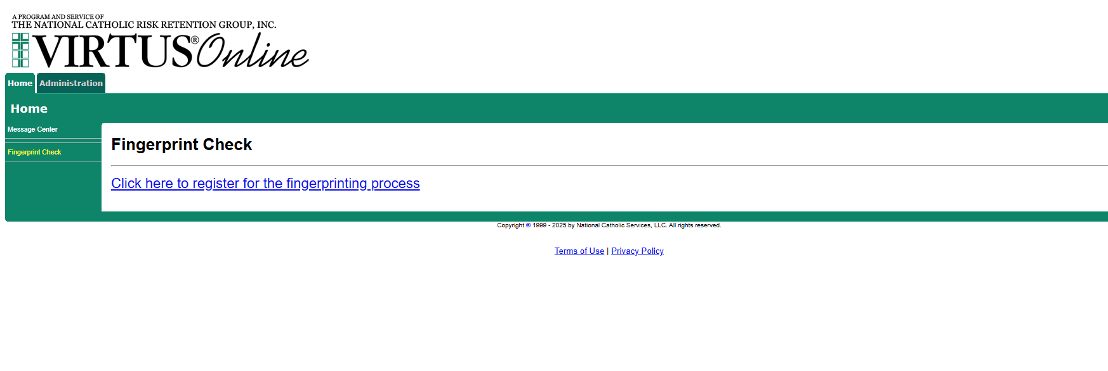

- And lastly, please fill out and sign the volunteer paperwork. It is available in the front office, or you can print it out yourself and return it to the office.
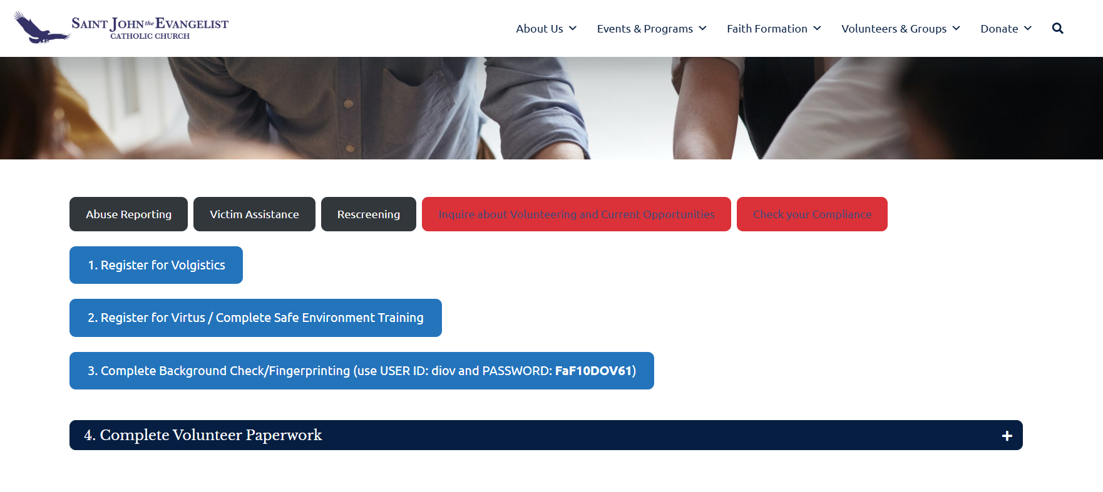

Once you have completed all the steps you can check back with us in one week to confirm the status of the background check. Call the office at, 239-566-8740 and we will be able to tell you if you are approved. Then let us know what ministry you are interested in, and we can get you started volunteering! Thank you!

